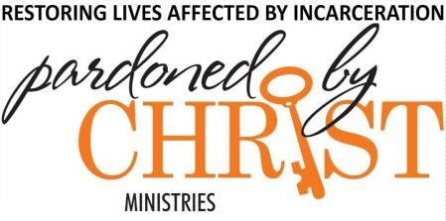

P.O. Box 1773

Cary, NC 27512

Contact: Roger Lague

Volunteer Coordinator

ralague@gmail.com

515-537-7777

_______________________________________________________________________

**PARDONED BY CHRIST MINISTRIES AND OPPORTUNITIES**

**MINISTRY TO MEN**

**Adult Bible Study, Discipleship and Worship Services**

* Wake Correctional Center: Monday night fellowship and mentorship. 7:00-8:30 pm and Sunday night Worship Service.
* Orange Correctional and Granville Correctional Worship Services.
* Community Passes: Mentor an adult inmate as you escort him on a community leave from prison. These passes are typically 4-6 hours and usually include taking the individual to church and out to eat.
* Visit men held in Wake County Jail.

**TRANSITIONAL HOUSES**

Volunteer to serve in one of four Transitional Houses.

Ministry needs include:

* Coach and mentor
* Bible study
* Financial budgeting/accounting
* Life skills/computer training
* Transportation
* Food services
* House and yard maintenance

**MINISTRY TO YOUTH**

**Youth Development Centers (YDC)**

Be a mentor for group and one-on-one interaction.

* Chatham YDC in Siler City. Ministry to girls and boys 14-18 years of age. 3rd Saturday, 1 pm-3pm.
* Edgecombe YDC in Rocky Mount. Ministry to boys 16-20 years of age. 3rd Sunday, 10 am-12pm.

**FAMILY SUPPORT MINISTRY**

If you or your family have a loved one that has been incarcerated or your family in any way has been affected by incarceration, PBC Ministries invites you to share your journey and be supported by others that are in similar circumstances. Our gatherings are facilitated with speakers, group interaction, and the development of one-on-one relationships.

FSM meets the 2nd and 4th Tuesday at 7 pm. Mostly by Zoom. Contact: Call 919-465-4498 or email pardonedbychrist@yahoo.com

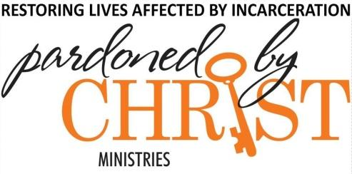

P.O. Box 1773

Cary, NC 27512

Contact: Roger Lague

Volunteer Coordinator

515-537-7777

ralague@gmail.com

_______________________________________________________________________

**Pardoned by Christ Volunteer Application**

1. **Name: __________________________________________________________________________________**

**First Middle Last**

1. **Mailing Address: __________________________________________________________________________**

**Street or PO Box City State Zip Code**

1. **Cell Phone #: _______________________________ Email: ______________________________________**
2. **Date of Birth: ____/____/_________ Gender: _____________ Race: ___________________________**
3. **Driver’s License #: ____________________________ State: ____________________________________**
4. **Have you ever served as a Volunteer with Pardoned by Christ? No___ If yes___, please list your start**

**Date: ________________________ / End date: _________________________**

1. **In what area(s) are you interested in serving as a Volunteer? ______________________________________**

1. **Why do you wish to serve as a Volunteer? _____________________________________________________**
2. **Have you ever been convicted of a crime other than a minor traffic violation? _______ Yes ________ No**

**If yes, please explain: __________________________________________Date:__________________________**

**I understand that I will not receive any compensation for serving as a volunteer with Pardoned by Christ. I understand that there are certain risks inherent in volunteering with Pardoned by Christ Ministries. PBC staff will take normal and prudent precautions for my protection but they cannot guarantee my physical safety nor protect me from any legal liability that may result from my actions as a volunteer. I am aware that my giving false information may result in the rejection of this application or termination of my volunteer status.**

**I have read this application and understand the information contained in it.**

**Date: _______________________ Signature: ________________________________________________________**